|  |
| --- |
| [Type the abstract of the document here. The abstract is typically a short summary of the contents of the document. Type the abstract of the document here. The abstract is typically a short summary of the contents of the document.] |

B.Sc III Physics(Hons) Sem V

**DC Power Supply**

study of rectification, filtering, voltage regulation and Current limiting action of DC Power Supply

BY ROHAN & Sanjay

Rectification

The task of converting alternating current (AC) to direct current(DC) is called Rectification, and those electronic circuits that convert AC to DC are called Rectifiers. The most common way to convert AC to DC is to use one or more diodes (electronic components which allow current to pass only in one direction).

Although a rectifier converts alternating current to direct current, the resulting direct current isn’t a steady voltage. It can be referred to as ‘Pulsating DC’. Though, this pulsating DC current always moves in the same direction, the voltage level has a distinct ripple through it. This ripple is due to the fact that whole of AC is not converted to DC, but some AC component is still retained. This extra AC component is known as Ripple, which rises and falls a bit in sync with the waveform of AC voltage that’s fed into the rectifier.

There are three distinct types of rectifiers that can be built using diodes viz.

* Half wave Rectifier
* Full wave Rectifier

1. Center Tapped Rectifiers
2. Bridge Rectifier

**Half-wave rectifier**

The simplest type of rectifier is made from a single diode. This type of rectifier is called a half wave because it passes just half of the AC input voltage to the output.

During the interval t=0 to t=T/2, the polarity of the applied voltage V1 is such as to establish pressure in the direction indicated and turn on the diode with the polarity appearing above the diode. The output signal is an exact replica of the applied signal. Hence, when the AC voltage is positive on the cathode side of the diode, the diode becomes forward biased and allows the current to pass through the output.

But when AC current reverses direction and becomes negative on the cathode side of the diode, i.e. for the period t=T/2 to t=T, due to reverse biasing, the polarity of input is negative causing the diode be in off state. The result is absence of path for current to flow. Hence, the diode blocks the current so that no voltage appears at the output.

If the V1 and output V0 are sketched together, we see a net positive area above the axis over a full period in the output signal V0 and average value is determined by

**VDC = 0.318 Vm**

Half wave rectifiers are simple enough to build but aren’t very efficient. That’s because the entire negative cycle of AC input is blocked by the rectifier. As a result, output voltage is zero half of the time. This causes average voltage at the output to be half of the input voltage.

**Full wave rectifier**

A full wave rectifier uses two or more diodes, which enables it to pass both the positive and negative side of AC input. The diodes are connected to the transformer. There are following two types of full wave transformer:

* Center Tapped Rectifier

Such a rectifier requires a center tapped transformer to establish the input signal across each section of secondary of transformer. Two diodes are connected to the two outer taps and the center tap is used as a common ground for the rectified DC voltage. It converts both halves of the AC sine wave to positive voltage direct current. In one half cycle, the first diode D1 is forward biased and it allows current to pass through, while D2 becomes reversed biased. The polarity of the diodes (Forward & Reverse) reverses for the next half cycle of input but the polarity for voltage across load resistor remains same. So, the net effect is that same output appears with same DC levels.

The result is DC voltage that pulses twice the frequency of input AC voltage. Here we can say,

**VDC = 2(0.318 Vm)**

**Or VDC = 0.636 Vm**

* Bridge Rectifier

The problem in the previous one is that it requires a center tapped transformer, so it produces DC that’s just half of the total output voltage of the transformer.

A bridge rectifier overcomes this problem by using four diodes instead of two. The diodes are arranged in a diamond pattern so that each half phase of the AC sine wave, two of the diodes pass the current to the positive and negative sides of the output, and other two diodes block the current i.e. during each of the half cycles, two diodes are forward biased and two diodes are reverse biased, alternatively. A bridge rectifier doesn’t require a center tapped transformer.

In first half cycle, D2 and D3 are conducting, whereas D1 and D4 are in off state. The load voltage V0 = V1 in case of ideal diode. For the next half cycle, polarity is reversed for diodes, but for load it remains same establishing a second pulsating wave.

The output from a bridge rectifier is pulsated DC just like tapped rectifier. However, the full voltage of transformer’s secondary coil is used. The DC voltage here will again have the same value as that of center tapped, i.e.

VDC = 0.636 Vm

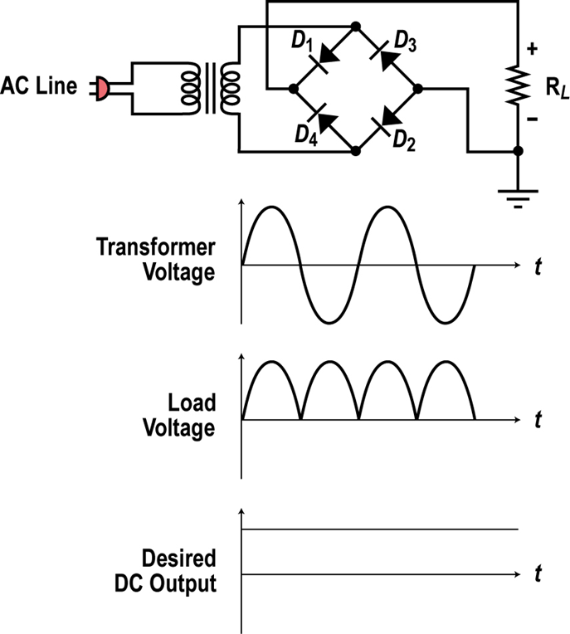

Ripple

The extra AC component present along with the DC at the output of a rectifier is known as Ripple. Ripple effects the working of any electronic device, since, more value of ripple means more amount of unwanted AC is present. A rectifier giving less value of ripples is preferred over the one giving more value.

* Ripple Factor

The ratio of output AC voltage to the output DC voltage is known as Ripple Factor.

R = EAC /EDC

Lesser value of AC component and larger value of DC component reduces the value of ripple factor and hence the unwanted ripple in the output.

For a half wave rectified signal, the output DC voltage is

VDC = 0.318 Vm

The rms value of AC component can be calculated as,

Vrms = 0.385 Vm

So, the ripple factor of a half wave rectified signal is,

R = Vrms/VDC = (0.385 Vm)/(0.318 Vm) = 1.21

For a full wave rectified signal,

VDC = 0.636 V­­ And Vrms = 0.308 Vm

So, Ripple Factor, **R = 0.481** for a full wave rectifier.

In simple words, a full wave rectified signal has fewer ripples than a half wave rectified signal and is thus better to apply a filter.

Filtering

Because of the alternating nature of the input AC sine wave, the process of rectification alone produces a DC current that, though unidirectional, consists of pulses of current i.e. it contains unwanted AC components along with DC components. This unwanted AC is termed as ripple. For most of the supply purposes, constant direct voltage is required than that furnished by a rectifier. Therefore, to reduce AC component from the rectified output voltage, a filter circuit is required. Thus, filter is a device, which passes DC component to the load and blocks the AC component of the rectified output. Filter is typically constructed from reactive circuit elements such as inductors, capacitors, resistors etc. Different types of filters studied in this experiment are:

* Inductive Filter

An inductor used as a filter is inserted between rectified and load resistance RL. This type of filter is also called Choke Filter. When the output of rectifier, containing both AC & DC components, passes through the inductor, it offers high resistance to the AC component and low resistance to the DC component. Therefore, AC component is blocked and only DC reaches the load. Since with increase in load resistance, the ripple factor also increases, so, the type of filter can be preferred only in the case of small values of load resistance.

* Capacitor Filter

In this filter, a capacitor is connected in parallel with the load. During the rise of the voltage cycle, it it gets charged and this charge is supplied to the load during the fall in the voltage cycle. The process is repeated for each cycle. It gives a good quality output at the large values of load resistance since the ripple here decreases with increase in the load resistance. It is popular because of its low cost, small size, less weight and good characteristics.

Summary

•In most AC to DC supplies, the 120 volt AC line is first filtered then stepped up or down to the desired voltage level then rectified into pulsating DC, then filtered to a constant DC. A regulator holds the output to a desired level. A DC-DC converter may also be used to generate another DC voltage.

•The two most common rectifiers are the single diode half wave rectifier and the four diode full wave bridge rectifier.